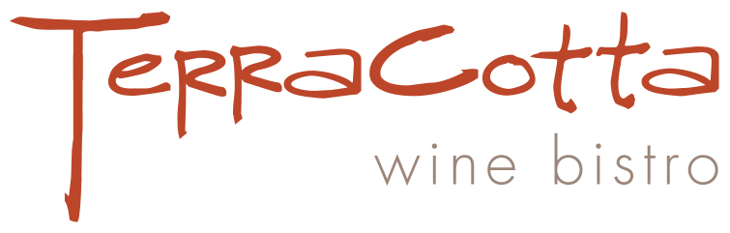

Thanksgiving Dinner 2019

Smoked Butternut Squash Bisque
~
Choice of:
Deep Fried Free Range Turkey
With Pan Gravy
Orange Cranberry Sauce

Oven Roasted & Garlic Rubbed Prime Rib
Au Jus ~ Horseradish Cream

Mushroom Shepherds Pie
Duxelles of Wild Woodland Mushrooms, Onion and Carrots
Crowned with Yukon Gold Mashed Potatoes

~
Cornbread Dressing with Toasted Walnuts and Chestnuts
(Or Gluten Free Herb Stuffing with Toasted Walnuts and Chestnuts)
Young Carrots with Honey Tarragon Glaze
Old Fashioned Yukon Gold Mashers
Green Beans with Tobacco Onions
~
Apple Tart with Maple Bourbon Pecan Praline Ice Cream
New York Style Cheesecake with Berry Sauce
Chocolate Pecan Pie

$50 per person
$25 for children 12 and under

