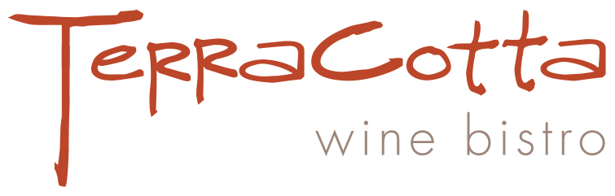

New Year’s Eve Prix-Fixe

Appetizer Choice:

Norwegian Trout Rose
Accented with Sturia Premium French Caviar
In a Phyllo Cup with Crème Fraiche, Minced Egg and Red Onion

Chef Catherine’s Lobster Bisque

Grilled Pear, Parmesan Frico and Pecan Salad
On a Nest of Crisp Greens ~ Pomegranate Vinaigrette

Entrée Choice

Gold Canyon Ranch Ribeye Steak
Prime Beef Rubbed with Spices ~ Seared on a Hot Grill
With Brandied Chanterelle and Shiitake Mushrooms Demi-Glace
Scalloped Yukon Gold Potatoes
Sautéed Market Vegetables

Maple Leaf Farms Roasted Duck Confit
Slowly Roasted Succulent Duck Leg and Thigh
With Dark Cherry and Tarragon Gastrique
Scalloped Yukon Gold Potatoes
Market Vegetables

Dessert Choice:

Chocolate ‘Martini’ Bombe
Rich Chocolate Brownie Drizzled with Raspberry Vodka
A Dollop of Chocolate Mousse
Whipped Cream and a Bordeaux Maraschino Cherry

Berries Jubilee
Assorted Ripe Berries Macerated in Grand Marnier
On Vanilla Bean Ice Cream

$75 per Person
Plus Tax and Gratuity

